**LAB # 04**



**FALL 2021**

**CSE102L Computer Programming Lab**

Submitted by: **MUHAMMAD UMAR JAN**

Registration No. : **1508**

Class Section: **B**

“On my honor, as student of University of Engineering and Technology, I have neither given nor received unauthorized assistance on this academic work.”

Submitted to:

**Engr. Abdullah Hamid**

21/1/2022

Department of Computer Systems Engineering

University of Engineering and Technology Peshawar

***QUESTION# 01***

***Step# 01***

First of all press window+R to open run and type CMD in search box.

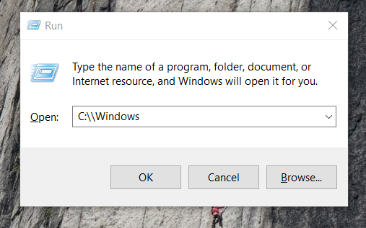

Here type CMD on the place of C:\\Windows.

***Step# 02***

Enter the command from window and tape ipconfig 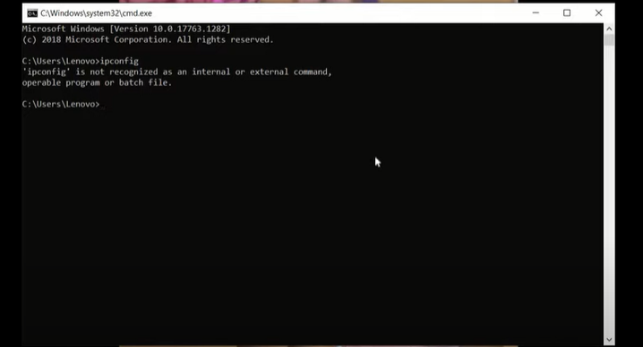

Step# 03

Copy the gateway IP address.

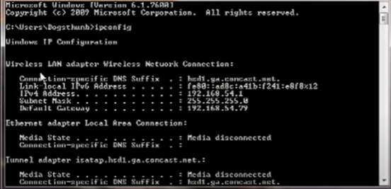.

STEP# 04

Open any Web Browser and give it the given IP address which is

192.168.54.99

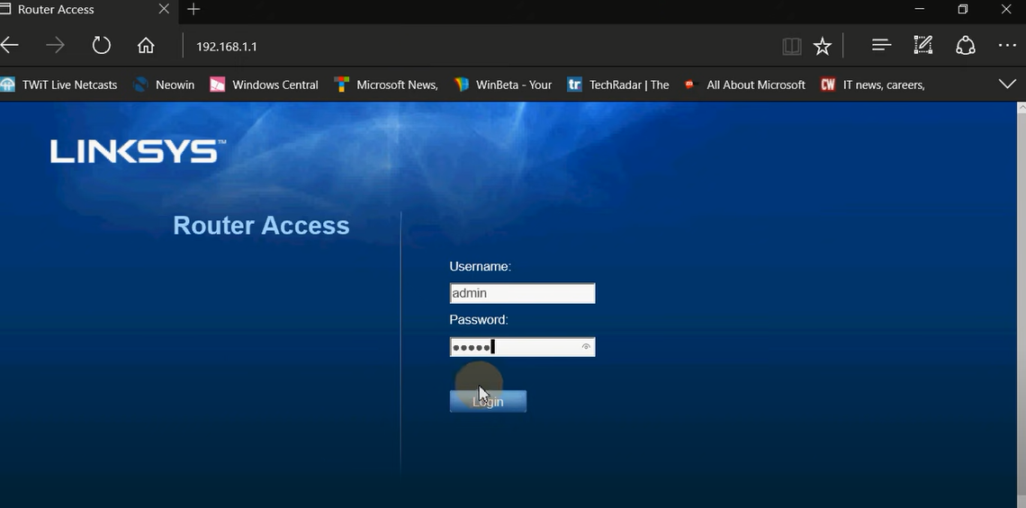

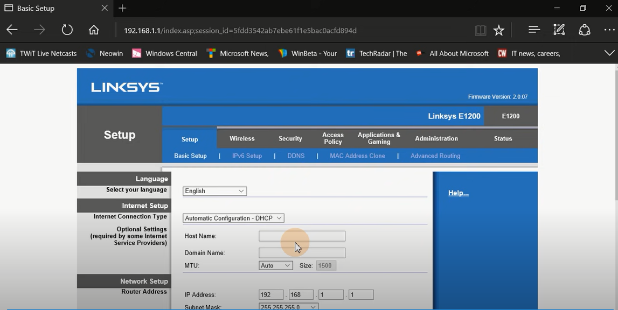

Step# 05

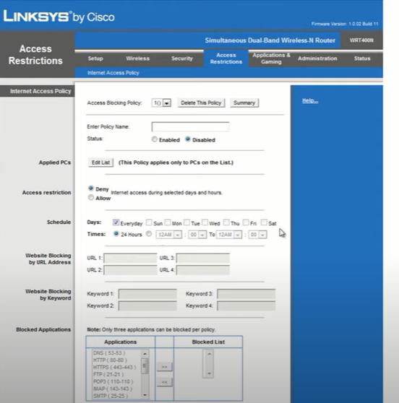

QUESTION# 02

Step#01

First open email compose a file greater then 30 MB.

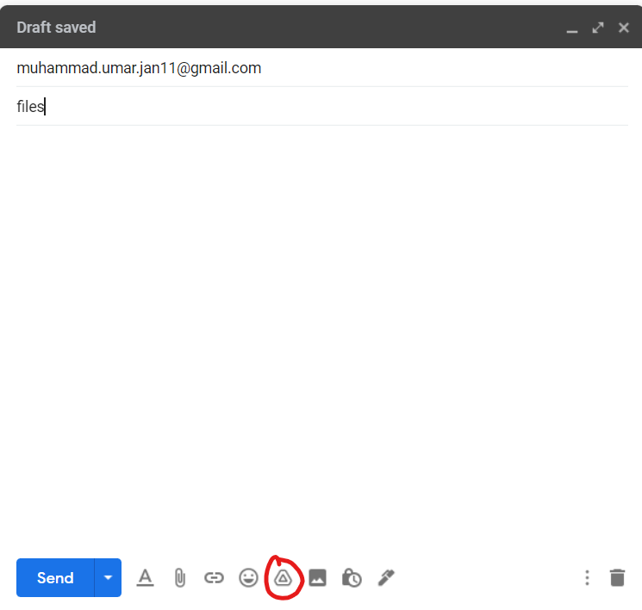

Step# 02

Select the file is greater than30 MB cause an error which can’t be sent.

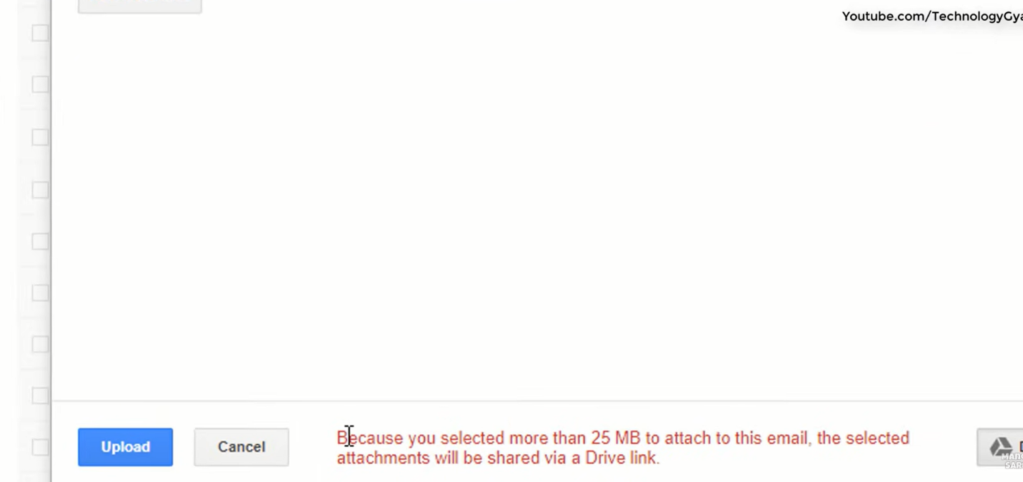

Step# 03

After that select the upload option.

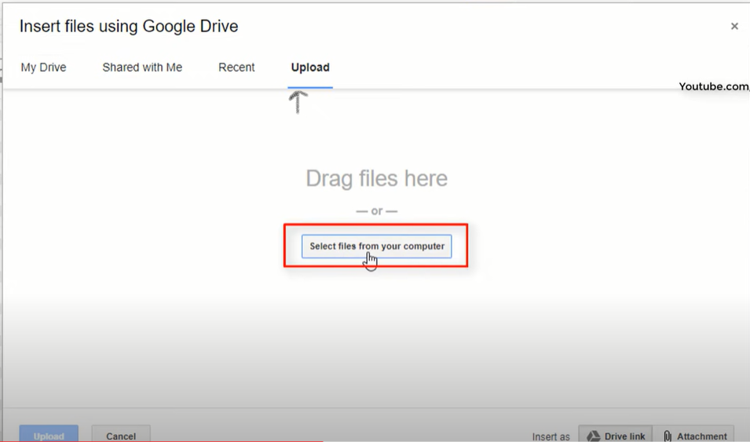

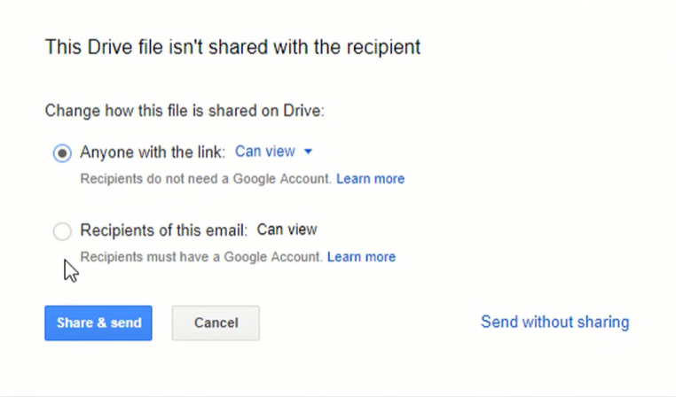

Step# 04

Uploading has been started.

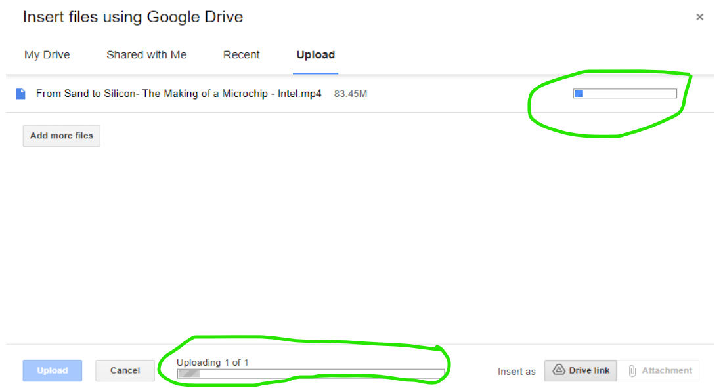

Step# 05

Uploading completed.

